**NAME:. SANDEEP SINGH**

**DEPARTMENT: ELECTRONICS AND COMMUNICATION ENGINEERING**

**COLLEGE: GOVERNMENT COLLEGE OF TECHNOLOGY COIMBATORE**

**NAAN MUDALVAN COURSE: DIGITAL MARKETING**

**NAAN MUDALVAN ID:. E9A5AA25997C8EE85EE4AB7188BB4555**

**ASSIGNMENT ON DIGITAL MARKETING**

**BlogSpot :**

1. **Creating a blog**

[**https://www.blogger.com/blog/post/edit/463037167439384059/5928555682362723374**](https://www.blogger.com/blog/post/edit/463037167439384059/5928555682362723374)

**Title:. “Capturing World the from All Angles: A Closer Look at the A-10 Triple Camera Mobile**

In the fast-paced world of digital marketing, where content is king and *visuals* are paramount, the A-10 Triple Camera Mobile is making waves. This brand, with its innovative approach to photography and user experience, is changing the game. Join us as we dive into the realm of A-10, exploring the power of triple camera technology and its impact on digital marketing.

The Power of Triple Cameras:

A-10’s Triple Camera Mobile isn’t just a phone; it’s a creative powerhouse. With three distinct lenses, this device is equipped to capture stunning photos and videos from various perspectives.

**”**

1. **Creating A-10 graphics:** [**https://omegafgh.blogspot.com/2023/10/infographics.html**](https://omegafgh.blogspot.com/2023/10/infographics.html)

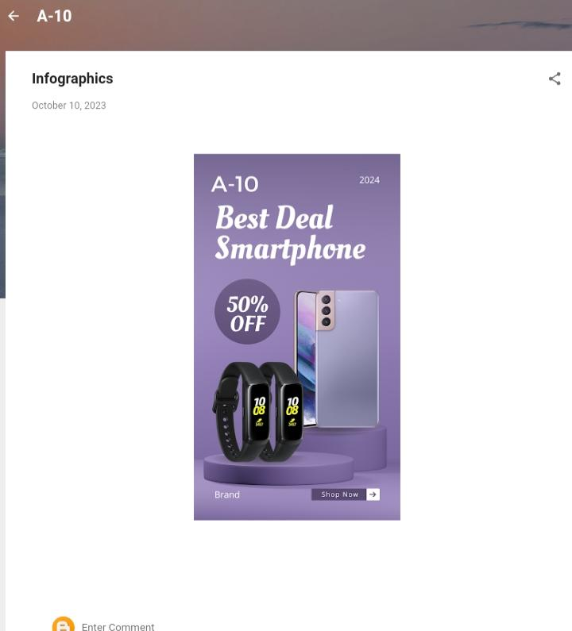

**3.Creating email news letter**

[**https://omegafgh.blogspot.com/2023/10/a-10-product-introduction.html**](https://omegafgh.blogspot.com/2023/10/a-10-product-introduction.html)

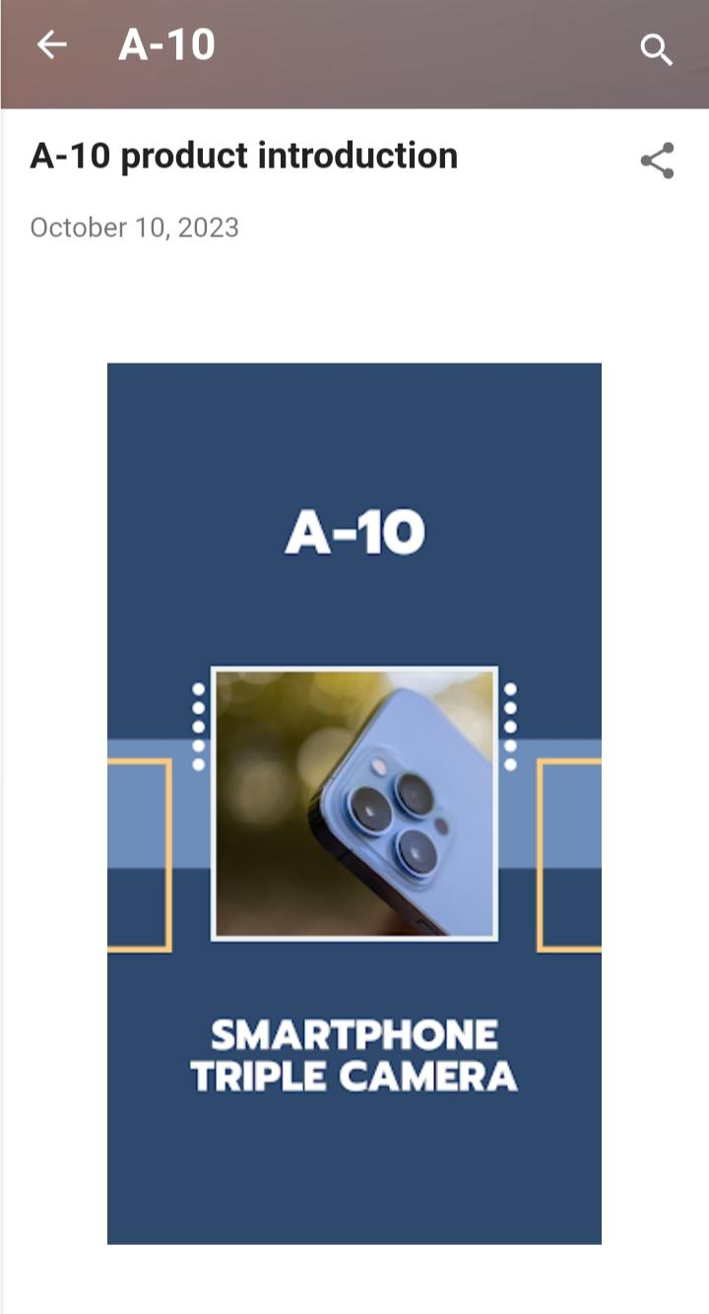**Email news letter**